Theme Designer
Theme Black and Blue
Manual Changes

<!--[GEOS2][skhade][12-02-2020][Change color from #FF666666 to #FF2AB7FF]-->
<SolidColorBrush x:Key="UnfocusedRowBrush"
Color="#FF2AB7FF"
cs:MetropolisLight.Color="#FFB9B9B9"/>

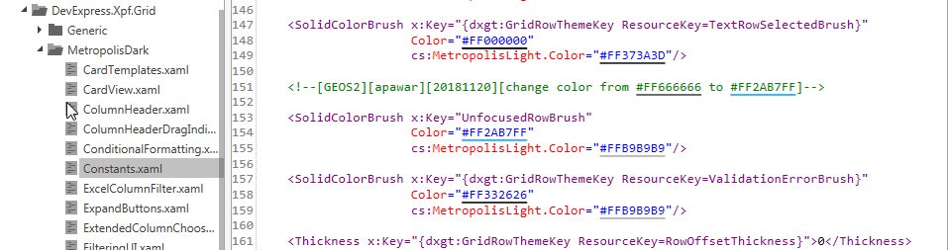

- <!--DXHeaderTemplate-->
<Grid x:Name="PART_Grid"
DockPanel.Dock="Right"
Focusable="False"
UseLayoutRounding="True">
<!--[GEOS2][skhade][12-02-2020]Added Margin="0,5,0,0"]-->
<ItemsControl Margin="0,5,0,0"
Style="{DynamicResource {dxt:DXTabbedWindowThemeKey ResourceKey=ButtonContainerStyle}}"
Visibility="Hidden">
<dxc:HeaderItemControl DockPanel.Dock="Right" Style="{DynamicResource {dxt:FloatingContainerThemeKey ResourceKey=FloatingContainerHeaderCloseButtonStyle}}"/>
</ItemsControl>
<!--[GEOS2][skhade][12-02-2020][Added Margin="0,5,0,0"]-->
<ItemsControl x:Name="PART_HeaderButtons"
Focusable="False"
IsTabStop="False"
Margin="0,5,0,0"
Style="{DynamicResource {dxt:DXTabbedWindowThemeKey ResourceKey=ButtonContainerStyle}}">
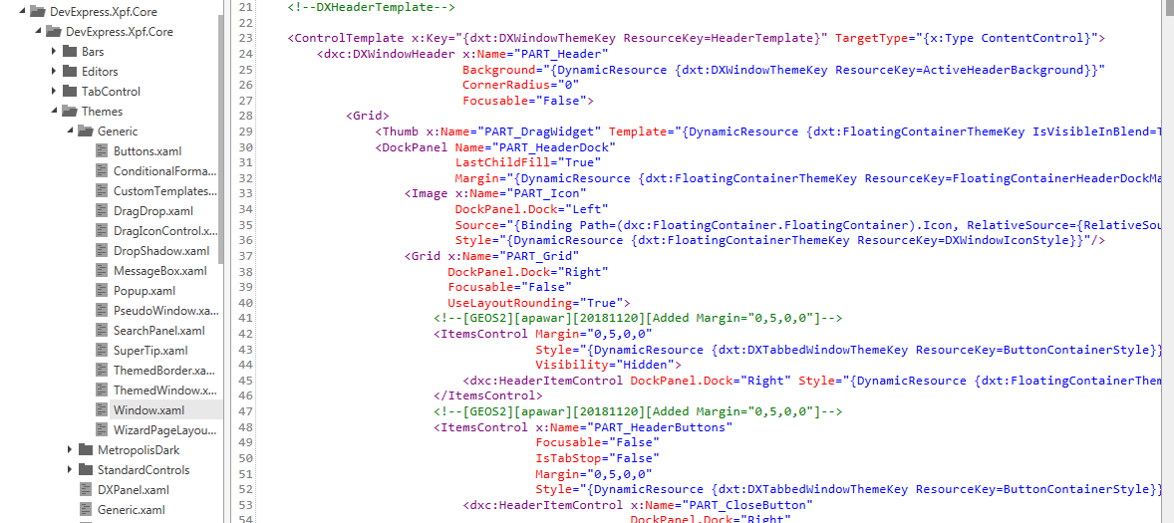

<!--FloatingContainerTamplate-->
<DataTemplate x:Key="{dxt:FloatingContainerThemeKey ResourceKey=FloatingContainerTemplate}">
<Grid TextElement.Foreground="{DynamicResource {dxt:ThemeColorsThemeKey ResourceKey=DXMessageBoxForegroundColor}}">
<Control x:Name="PART_ActiveBorder"
Focusable="False"
Template="{DynamicResource {dxt:DXWindowThemeKey ResourceKey=FloatingActiveBorder}}"/>
<Control x:Name="PART_InactiveBorder"
Focusable="False"
Template="{DynamicResource {dxt:DXWindowThemeKey ResourceKey=FloatingInactiveBorder}}"
Visibility="Collapsed"/>
<Grid Margin="{DynamicResource {dxt:DXWindowThemeKey ResourceKey=FloatingContainerBorderPadding}}">
<Grid.RowDefinitions>
<!--[GEOS2][skhade][12-02-2020]Set Height Auto to 20]-->
<RowDefinition Height="20"/>
<RowDefinition/>
</Grid.RowDefinitions>
<ContentControl x:Name="Header"
dxc:HeaderItemControl.CloseTemplateProvider="{DynamicResource {dxt:DXWindowThemeKey ResourceKey=HeaderItemControlCloseTemplateProvider}}"
dxc:HeaderItemControl.CommonTemplateProvider="{DynamicResource {dxt:DXWindowThemeKey ResourceKey=HeaderItemControlCommonTemplateProvider}}"
Focusable="False"
Template="{DynamicResource {dxt:DXWindowThemeKey ResourceKey=HeaderTemplate}}"/>
<Grid x:Name="PART_ContentOffset"
Grid.Row="1"
Margin="{Binding Path=(dxc:FloatingContainerControl.ContentOffset), RelativeSource={RelativeSource Self} }">
<Control x:Name="PART_ContentBackground"
Focusable="False"
Template="{DynamicResource {dxt:DXWindowThemeKey ResourceKey=FloatingBackground}}"/>
<Control x:Name="PART_InactiveContentBackground"
Focusable="False"
Template="{DynamicResource {dxt:DXWindowThemeKey ResourceKey=InactiveFloatingBackground}}"
Visibility="Collapsed"/>
<!--[GEOS2][skhade][12-02-2020][Set Grid Margin 1 to 0]-->
<Grid Margin="0">
<Grid.RowDefinitions>
<RowDefinition Height="*"/>
<RowDefinition Height="Auto"/>
</Grid.RowDefinitions>
<ContentPresenter x:Name="PART_ContainerContent" Content="{Binding}"/>
</Grid>
</Grid>
</Grid>

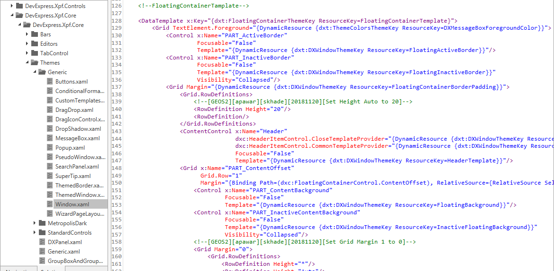

<!--Thickness-->
<!--[GEOS2][skhade][12-02-2020][Set all thickness 0]-->
<Thickness x:Key="{dxt:DXWindowThemeKey ResourceKey=ResizeBorderThickness}">0</Thickness>
<Thickness x:Key="{dxt:DXWindowThemeKey ResourceKey=BorderEffectOffset}">0</Thickness>
<Thickness x:Key="{dxt:DXWindowThemeKey ResourceKey=BorderEffectLeftMargins}">0, 0, 0, 0</Thickness>
<Thickness x:Key="{dxt:DXWindowThemeKey ResourceKey=BorderEffectRightMargins}">0, 0, 0, 0</Thickness>
<Thickness x:Key="{dxt:DXWindowThemeKey ResourceKey=BorderEffectTopMargins}">0</Thickness>
<Thickness x:Key="{dxt:DXWindowThemeKey ResourceKey=BorderEffectBottomMargins}">0</Thickness>
<Thickness x:Key="{dxt:DXWindowThemeKey ResourceKey=SizeGripMargin}">0,0,0,0</Thickness>
<Thickness x:Key="{dxt:DXWindowThemeKey ResourceKey=FloatingContainerBodyMargin}">0,0,0,0</Thickness>
<Thickness x:Key="{dxt:DXWindowThemeKey ResourceKey=FloatingContainerBorderPadding}">0</Thickness>
<Thickness x:Key="{dxt:FloatingContainerThemeKey ResourceKey=FloatingContainerHeaderDockMargin}">0,0,0,0</Thickness>
<Thickness x:Key="{dxt:FloatingContainerThemeKey ResourceKey=HeaderItemsControlMargin}">0</Thickness>

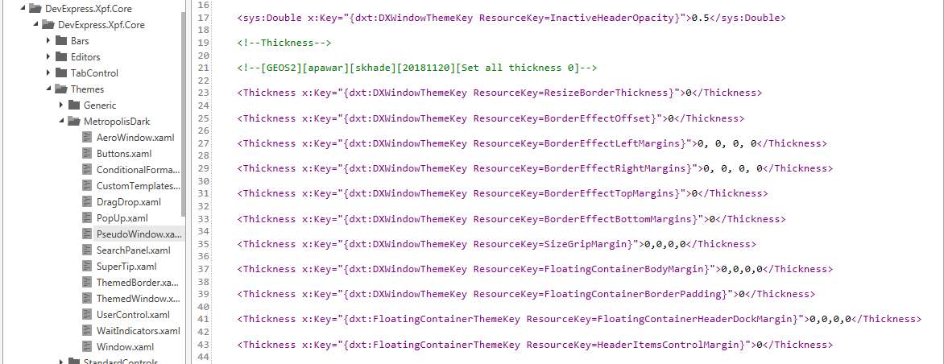

<Style x:Key="DefaultButtonContainerStyle" TargetType="ItemsControl">
<Setter Property="Template">
<Setter.Value>
<ControlTemplate TargetType="ItemsControl">
<!-- [GEOS2][skhade][12-02-2020]Added Margin property as Margin="0,-15,0,0"]-->
<ItemsPresenter Margin="0,-15,0,0" VerticalAlignment="Stretch"/>
</ControlTemplate>
</Setter.Value>
</Setter>
<Setter Property="ItemsPanel">
<Setter.Value>
<ItemsPanelTemplate>
<DockPanel LastChildFill="False"/>
<!--<StackPanel Orientation="Horizontal" VerticalAlignment="Center"/>-->
</ItemsPanelTemplate>
</Setter.Value>
</Setter>
</Style>

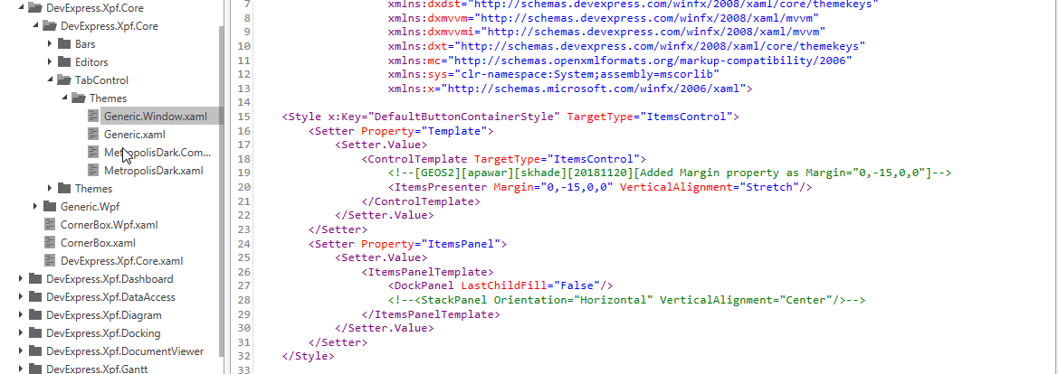

- <Style x:Key="{dxdst:DefaultStyleThemeKey FullName=DevExpress.Xpf.Navigation.TileBar}" TargetType="dxnav:TileBar">
<Setter Property="dxcop:ScrollableControl.ScrollButtonMode" Value="Default"/>
<!--[GEOS2][apawar][skhade][20171121][Set padding ="20,5,20,5"]-->
<Setter Property="Padding" Value="20,5,20,5"/>
<Setter Property="Template">
<Setter.Value>
<ControlTemplate TargetType="dxnav:TileBar">
<Border Background="{TemplateBinding Background}"
BorderBrush="{TemplateBinding BorderBrush}"
BorderThickness="{TemplateBinding BorderThickness}">
<Grid>
<dxcop:FlyoutDecorator x:Name="PART_TileNavFlyoutDecorator" FlyoutShowMode="{TemplateBinding FlyoutShowMode}"/>
<dxcop:ScrollableControl x:Name="PART_ScrollableControl"
Orientation="{TemplateBinding Orientation}"
ScrollButtonMode="{Binding Path=(dxcop:ScrollableControl.ScrollButtonMode), RelativeSource={RelativeSource TemplatedParent}}">
<ItemsPresenter x:Name="PART_ItemsPresenter"/>
</dxcop:ScrollableControl>
</Grid>
</Border>
</ControlTemplate>
</Setter.Value>
</Setter>

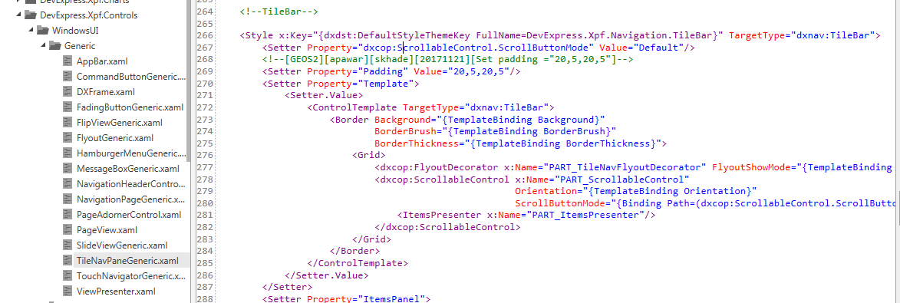

- <Style x:Key="{dxdst:DefaultStyleThemeKey FullName=DevExpress.Xpf.WindowsUI.PageView}" TargetType="{x:Type dxwui:PageView}">
<Setter Property="Template" Value="{DynamicResource {dxwuit:PageViewElementsThemeKey ResourceKey=Template}}"/>
<Setter Property="TemplateRight" Value="{DynamicResource {dxwuit:PageViewElementsThemeKey ResourceKey=TemplateRight}}"/>
<Setter Property="TemplateLeft" Value="{DynamicResource {dxwuit:PageViewElementsThemeKey ResourceKey=TemplateLeft}}"/>
<Setter Property="TemplateTop" Value="{DynamicResource {dxwuit:PageViewElementsThemeKey ResourceKey=Template}}"/>
<Setter Property="TemplateBottom" Value="{DynamicResource {dxwuit:PageViewElementsThemeKey ResourceKey=TemplateBottom}}"/>
<Setter Property="ItemsPanel" Value="{DynamicResource {dxwuit:PageViewElementsThemeKey ResourceKey=ItemsPanel}}"/>
<Setter Property="Background" Value="{DynamicResource {dxwuit:PageViewElementsThemeKey ResourceKey=Background}}"/>
<!--[GEOS2][skhade][12-02-2020][Set padding to 0]-->
<Setter Property="Padding" Value="0,0,0,0"/>
<!--SPECIFICTHEME VS2010 <Setter Property="Foreground" Value="{DynamicResource {dxwuit:PageViewElementsThemeKey ResourceKey=Foreground}}" /> SPECIFICTHEME-->
</Style>

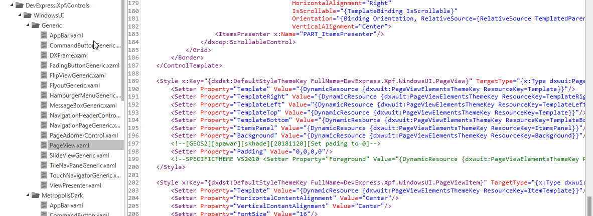

- <Setter Property="Template">
<Setter.Value>
<ControlTemplate TargetType="dxwui:MenuFlyoutItem">
<Grid x:Name="Root"
Background="{TemplateBinding Background}"
SnapsToDevicePixels="{TemplateBinding SnapsToDevicePixels}">
<VisualStateManager.VisualStateGroups>
<VisualStateGroup x:Name="CommonStates">
<VisualState x:Name="MouseOver">
<Storyboard>
<!--[GEOS2][skhade][12-02-2020][Set DoubleAnimation Duration="0" To="0"]-->
<DoubleAnimation Duration="0"
Storyboard.TargetName="HoverState"
Storyboard.TargetProperty="Opacity"
To="0"/>
<ObjectAnimationUsingKeyFrames Storyboard.TargetName="content" Storyboard.TargetProperty="Foreground">
<DiscreteObjectKeyFrame KeyTime="0" Value="{DynamicResource ResourceKey={dxwuit:MenuFlyoutElementsThemeKey ResourceKey=SelectedForeground}}"/>
</ObjectAnimationUsingKeyFrames>
</Storyboard>
</VisualState>
<VisualState x:Name="Pressed">
<Storyboard>
<!--[GEOS2][skhade][12-02-2020][Set DoubleAnimation Duration="0" To="0"]-->
<DoubleAnimation Duration="0"
Storyboard.TargetName="PressedState"
Storyboard.TargetProperty="Opacity"
To="0"/>
<ObjectAnimationUsingKeyFrames Storyboard.TargetName="content" Storyboard.TargetProperty="Foreground">
<DiscreteObjectKeyFrame KeyTime="0" Value="{DynamicResource ResourceKey={dxwuit:MenuFlyoutElementsThemeKey ResourceKey=PressedForeground}}"/>
</ObjectAnimationUsingKeyFrames>
</Storyboard>
</VisualState>
<VisualState x:Name="Disabled">
<Storyboard>
<DoubleAnimation Duration="0"
Storyboard.TargetName="Root"
Storyboard.TargetProperty="Opacity"
To="0.35"/>
</Storyboard>
</VisualState>
<VisualState x:Name="Normal"/>
</VisualStateGroup>
</VisualStateManager.VisualStateGroups>
<!--[GEOS2][apawar][20181120][Set HoverState Background from ="{DynamicResource ResourceKey={dxwuit:MenuFlyoutElementsThemeKey ResourceKey=SelectedBackground}}" to "Transparent"]-->
<Border x:Name="HoverState"
Background="Transparent"
Opacity="0"
cs:id="Border_0000"/>
<Border x:Name="PressedState"
Background="{DynamicResource ResourceKey={dxwuit:MenuFlyoutElementsThemeKey ResourceKey=PressedBackground}}"
Opacity="0"/>
<dxwuii:MenuFlyoutItemContentPresenter x:Name="content"
Content="{TemplateBinding Content}"
ContentTemplate="{TemplateBinding ContentTemplate}"
ContentTemplateSelector="{TemplateBinding ContentTemplateSelector}"
Focusable="False"
Foreground="{TemplateBinding Foreground}"
HorizontalAlignment="{TemplateBinding HorizontalContentAlignment}"
Margin="{TemplateBinding Padding}"
VerticalAlignment="{TemplateBinding VerticalContentAlignment}"/>
</Grid>
</ControlTemplate>
</Setter.Value>
</Setter>
</Style>

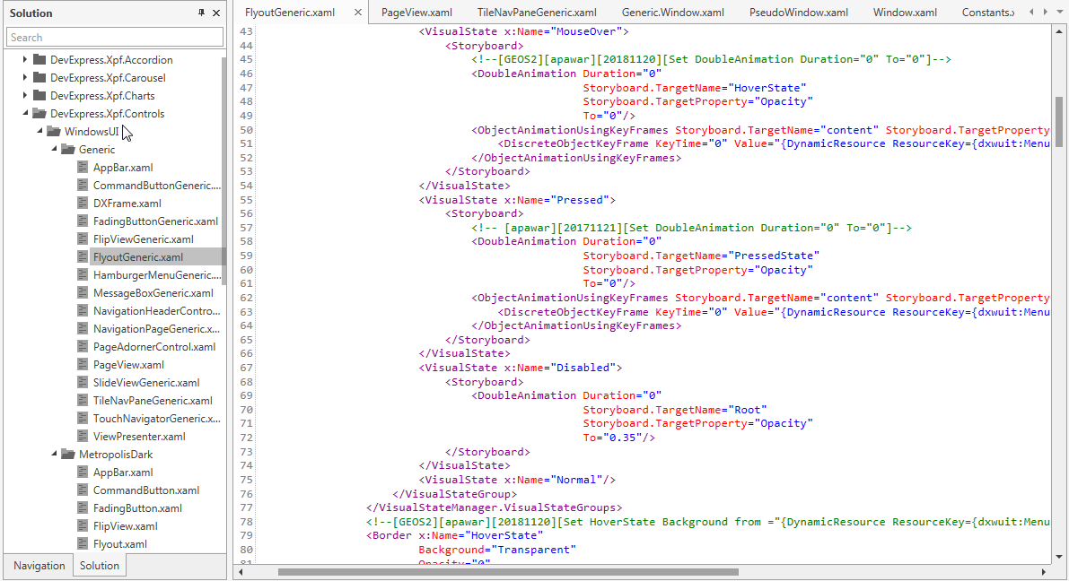

- <!-- Glyph -->
<!--[GEOS2][skhade][12-02-2020][Modify Width="27" to "15" Height="25" to "12"]-->
<DataTemplate x:Key="{dxwuit:CommandButtonElementsThemeKey ResourceKey=BackGlyph}">
<Path Data="F1 M 305,875L 305,874L 317,862L 321,862L 310,873L 332,873L 332,876L 310,876L 321,887L 317,887L 305,875 Z "
Height="12"
Stretch="Fill"
Width="15"/>
</DataTemplate>
<!-- Glyph -->
<!-- [GEOS2][skhade][12-02-2020][modify Width="27" to "15" Height="25" to "12"]-->
<DataTemplate x:Key="{dxwuit:CommandButtonElementsThemeKey ResourceKey=ForwardGlyph}">
<Path Data="F1 M 305,875L 305,874L 317,862L 321,862L 310,873L 332,873L 332,876L 310,876L 321,887L 317,887L 305,875 Z "
Height="12"
RenderTransformOrigin="0.5,0.5"
Stretch="Fill"
Width="15">
<Path.RenderTransform>
<ScaleTransform ScaleX="-1"/>
</Path.RenderTransform>
</Path>
</DataTemplate>
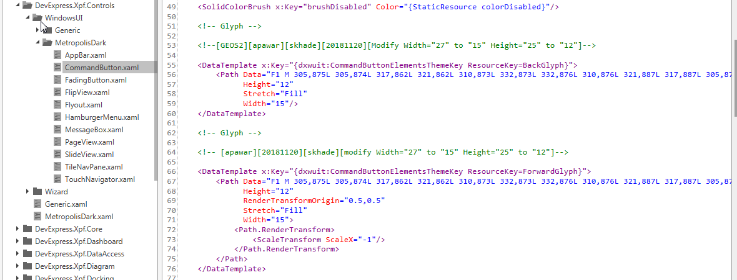

<!-- Template -->
<ControlTemplate x:Key="{dxwuit:CommandButtonElementsThemeKey ResourceKey=Template}" TargetType="dxwui:CommandButton">
<Grid SnapsToDevicePixels="True">
<!--[GEOS2][skhade][12-02-2020][Modify size of ellipse MinHeight=20 and MinWidth=20]-->
<Ellipse x:Name="border"
Fill="{StaticResource ellipseFillDefault}"
MinHeight="20"
MinWidth="20"
Stroke="{StaticResource ellipseStrokeDefault}"
StrokeThickness="3"
UseLayoutRounding="True">
<dxi:Interaction.Behaviors>
<dxwuii:ConstrainedSizeBehavior/>
</dxi:Interaction.Behaviors>
</Ellipse>
<dxwuii:ShapeContentPresenter x:Name="content"
Foreground="{StaticResource pathColorDefault}"
HorizontalAlignment="Center"
VerticalAlignment="Center"/>
<VisualStateManager.VisualStateGroups>
<VisualStateGroup x:Name="CommonStates">
<VisualState x:Name="Normal"/>
<VisualState x:Name="MouseOver">

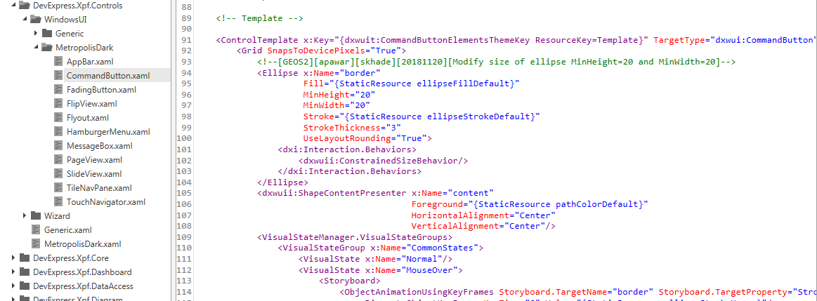

<!--Pushpin-->
<!--[GEOS2][skhade][12-02-2020] Change color-->
<SolidColorBrush x:Key="{dxt:MapBrushesThemeKey ResourceKey=PushpinBackground}" Color="#FF8AFBFF"/>
<!-- previous color = #FF999999 -->
<SolidColorBrush x:Key="{dxt:MapBrushesThemeKey ResourceKey=PushpinForeground}"
Color="#FF333333"
cs:MetropolisLight.Color="#FF8AFBFF"/>
<!-- previous color = #FF373A3D -->
<SolidColorBrush x:Key="{dxt:MapBrushesThemeKey ResourceKey=PushpinSelectionBrush}" Color="#FFFF0000"/>
<!-- previous color = #FF083493 OR #FF2AB7FF -->
<SolidColorBrush x:Key="{dxt:MapBrushesThemeKey ResourceKey=PushpinSelectionForeground}"
Color="#FF333333"
cs:MetropolisLight.Color="#FFFF0000"/>
<!-- previous color = #FFFFFFFF -->

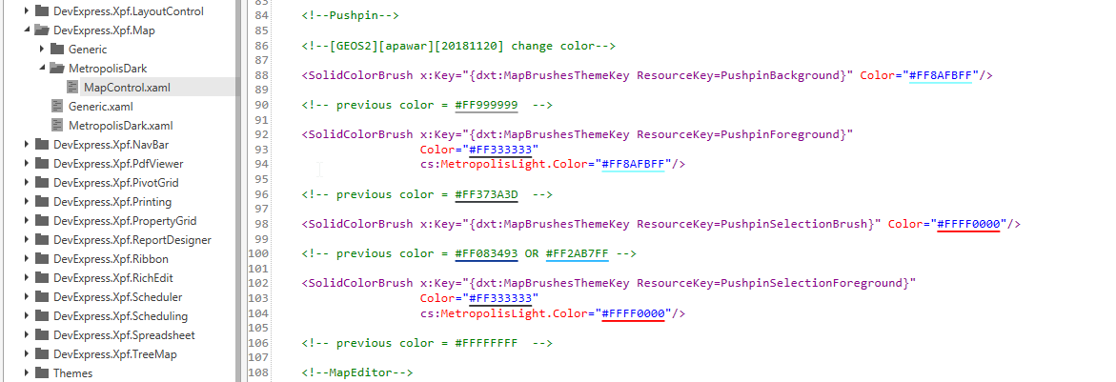

- <!-- Colors -->
<!--[GEOS2][apawar][Comment 1][20171121][Set from FF333333 to #FFFFFFFF]-->
<!--[GEOS2][apawar][Comment 2][20171121][Set from FF333333 to #FF2AB7FF]-->
<!--[GEOS2][apawar][Comment 3][20171121][Set from FF2AB7FF to #FF000000]-->
<!-- [Comment 3] -->
<SolidColorBrush x:Key="{dxwuit:AppBarElementsThemeKey ResourceKey=Background}" Color="#FF000000"/>
<SolidColorBrush x:Key="{dxwuit:AppBarElementsThemeKey ResourceKey=AppBarButtonForeground}"
Color="#FF333333"
cs:MetropolisLight.Color="#FFFFFFFF"/>
<!-- [Comment 1] -->
<Color x:Key="{dxwuit:AppBarElementsThemeKey ResourceKey=AppBarButtonForegroundColor}">#FFFFFFFF</Color>
<system:Double x:Key="{dxwuit:AppBarElementsThemeKey ResourceKey=AppBarButtonDefaultWidth}">100</system:Double>
<!-- [Comment 1] -->
<Color x:Key="contentColor">#FFFFFFFF</Color>
<!-- [Comment 2] -->
<Color x:Key="contentColorHover" cs:MetropolisLight.Color="#FFFFFFFF">#FF2AB7FF</Color>
<Color x:Key="contentColorPressed">#FF2AB7FF</Color>
<Color x:Key="contentColorChecked">#FF2AB7FF</Color>
<Color x:Key="contentColorHoverChecked">#FF2AB7FF</Color>
<Color x:Key="contentColorPressedChecked" cs:MetropolisLight.Color="#FFFFFFFF">#FF333333</Color>
<SolidColorBrush x:Key="contentBrush" Color="{StaticResource contentColor}"/>
<!-- [Comment 1] -->
<SolidColorBrush x:Key="borderBrush" Color="#FFFFFFFF"/>
<SolidColorBrush x:Key="backBrush"
Color="#00333333"
cs:MetropolisLight.Color="#00FFFFFF"/>
<SolidColorBrush x:Key="contentBrushHover" Color="{StaticResource contentColorHover}"/>
<!-- [Comment 2] -->
<SolidColorBrush x:Key="borderBrushHover"
Color="#FF2AB7FF"
cs:MetropolisLight.Color="#FFFFFFFF"/>
<SolidColorBrush x:Key="backBrushHover"
Color="#3F333333"
cs:MetropolisLight.Color="#3FFFFFFF"/>
<SolidColorBrush x:Key="contentBrushPressed" Color="{StaticResource contentColorPressed}"/>
<!-- [Comment 2] -->
<SolidColorBrush x:Key="borderBrushPressed"
Color="#FF2AB7FF"
cs:MetropolisLight.Color="#FFFFFFFF"/>
<SolidColorBrush x:Key="backBrushPressed"
Color="#FF333333"
cs:MetropolisLight.Color="#FFFFFFFF"/>
<SolidColorBrush x:Key="contentBrushChecked" Color="{StaticResource contentColorChecked}"/>
<!-- [Comment 1] -->
<SolidColorBrush x:Key="borderBrushChecked" Color="#FFFFFFFF"/>
<SolidColorBrush x:Key="backBrushChecked"
Color="#FF333333"
cs:MetropolisLight.Color="#FFFFFFFF"/>
<SolidColorBrush x:Key="contentBrushHoverChecked" Color="{StaticResource contentColorHoverChecked}"/>
<!-- [Comment 2] -->
<SolidColorBrush x:Key="borderBrushHoverChecked"
Color="#FF2AB7FF"
cs:MetropolisLight.Color="#FFFFFFFF"/>
<SolidColorBrush x:Key="backBrushHoverChecked"
Color="#FF333333"
cs:MetropolisLight.Color="#FFFFFFFF"/>
<SolidColorBrush x:Key="contentBrushPressedChecked" Color="{StaticResource contentColorPressedChecked}"/>
<SolidColorBrush x:Key="borderBrushPressedChecked"
Color="#FF333333"
cs:MetropolisLight.Color="#FFFFFFFF"/>
<SolidColorBrush x:Key="backBrushPressedChecked"
Color="#00333333"
cs:MetropolisLight.Color="#00FFFFFF"/>
<Thickness x:Key="AppBarTileButtonPressedMargin">2</Thickness>
<SolidColorBrush x:Key="{dxwuit:AppBarElementsThemeKey ResourceKey=AppBarTileButtonBackground}"
Color="#FF333333"
cs:MetropolisLight.Color="#FFFFFFFF"/>
<SolidColorBrush x:Key="AppBarTileButtonForeground" Color="#FF2AB7FF"/>
<Color x:Key="AppBarTileButtonForegroundColor">#FF2AB7FF</Color>

